# **PC Requirement**

* **CPU**: Intel E3400 or higher, Frequency: 2GHz+
* **Memory**: 4GB+
* **OS**: Windows XP/Windows 7 version.
* **USB2.0 root hub is a must, NO USB 1.1 root hub is allowed.**

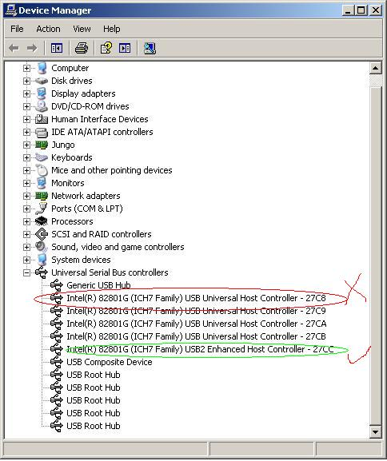

* **External USB hub is allowed with restrictions below:**
  + **Must use independent power supply**
  + **Must pass the compliance test of USB org, Belkin USB hub is recommended.**
  + **No more than 4 devices are allowed to be connected to USB hub.**
* **Step 1**

Set the correct boot mode and connect the OTG port to the PC on which the MFG Tool application will be run.

After connecting to PC with the correct boot mode setting, a HID-compliant device will be shown in the Device Manager as shown below: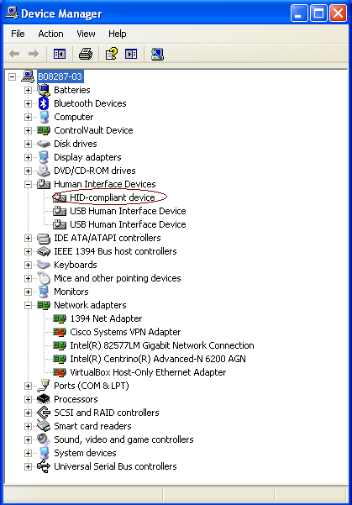

* **Step 2**

Double click the application to run.

There is a limitation that, when using the MFGTool V2 for the first time to run an image on a device, the device must be connected to PC before MFGTool V2 starts running.

Only two buttons can be clicked, Start/Stop, and Exit.

Start/Stop is used to start/stop the process.

Exit is used to exit this application. Please note that you can exit the application only after you stop the process.

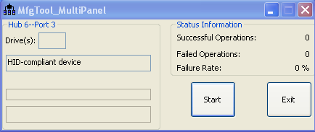

* **Step 4**

Click “Start” button. If you have a terminal tool to monitor the debug serial port of your board, it is suggested to open it. You can get more information from it.

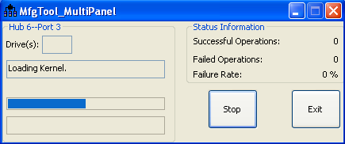

Process continuing:

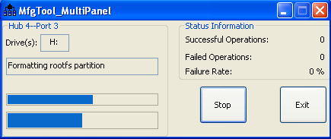

**You can find information from the terminal.**

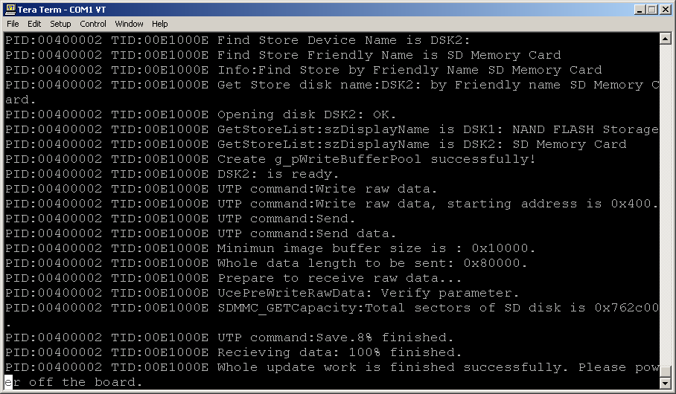

It is done. Click **“Stop” to finish, and Click “Exit” to terminate the application.**

